ASTRONOMY AND MATHEMATICS IN MESOAMERICA

National Endowment for the Humanities: Dialogues in the Americas (Mexican Literature and Culture in Context)

Prepared by Alex Cardiasmenos
16 August 2011

Unit Plan: Astronomy and Mathematics in Mesoamerica

Summary: This unit is designed to help students relate their knowledge of modern mathematics and astronomy with that of an ancient culture. The main focus will be to familiarize students with how advanced some of these cultures were, and how many facets of modern technology are similar to that of Mesoamerican technology. Although the title says Mesoamerica, the majority of activities presented in this unit are based on the Mayan civilization for purpose of brevity. Aztec, Toltec or Zapotec technologies could be added or substituted in per the instructor’s preference in order to bolster or extend instruction.

Level: Eighth Grade (Physical Science or Social Studies)

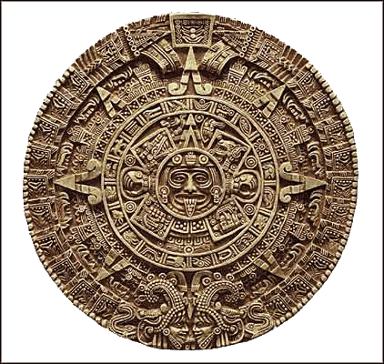
Piedra del Sol (Calendario Azteca)
(courtesy www.google.com)

Focus/Objectives:
Students will become familiar with mathematical and astronomical systems in the Mesoamerican/Pre-Colombian world. In order to achieve this, students will:
a. Demonstrate a basic understanding of the Mayan mathematical system, including the importance of the Mayan concept of zero.
b. Understand that Mesoamerican cultures (such as the Aztecs) used mathematics and astronomy to produce an accurate calendar.
c. Learn the importance of certain astrological events and celestial bodies, and how the Mayan understood them.
d. Compare astronomical and mathematical conventions of Mesoamerican times to modern day science.
California Science Standards -- GRADE EIGHT

4a. Students know galaxies are clusters of billions of stars and may have different shapes.

4b. Students know that the Sun is one of many stars in the Milky Way galaxy and that stars may differ in size, temperature, and color.

4c. Students know how to use astronomical units and light years as measures of distances between the Sun, stars, and Earth.

4d. Students know that stars are the source of light for all bright objects in outer space and that the Moon and planets shine by reflected sunlight, not by their own light.

4e. Students know the appearance, general composition, relative position and size, and motion of objects in the solar system, including planets, planetary satellites, comets, and asteroids.

California ELD Standards – GRADE 6-8

Intermediate: Use more complex vocabulary and sentences appropriate for language arts and other content areas (e.g., math, science, history–social science).

Early-Advanced/Advanced: Use appropriate language variations and genres in writing for language arts and other content areas (e.g., math, science, history–social science).

Preparation for the Instructor
In order to effectively teach this unit, the instructor should
- Learn the vigesimal system used by the Maya and other Mesoamerican cultures.
- Spend some time creating a big book to engage students. A PowerPoint presentation would appear to be the most simple way of doing this, but having something tangible may end up being more engaging (although time costly).
- Familiarize himself/herself with the Aztec concept of time, and the calendar system.
All of what is mentioned can be learned through the items in the resource section.
Guiding Question (to be asked throughout the unit):

How does what you learned today differ from what you have previously learned in mathematics or science?

Unit Vocabulary: glyph, lunar calendar, solar calendar, vigesimal system, Mesoamerica, Maya, Aztec

Unit Plan: Day by day
Activity 1 (50-60 minutes)
Instructor will provide a big book (PowerPoint or on poster) to lead a motivational/introductory activity. Students will be given an overview of certain important themes that will be covered during the unit. To start, the instructor should include a map of Mexico and Central America, and discuss what constitutes a Mesoamerican or Pre-Columbian culture. The instructor should also present two or three “teaser” facts with pictures to motivate and introduce the topics to students.
After guiding students through an overview of Mesoamerican astronomy and mathematics, students will participate in a teacher led KWL chart (Know-Want to know-Learned). Students will share some previous pieces of information that they already knew, several points of interest triggered by the big book, and at the end of the unit, what they learned.

To close the activity, an explanation of awards will be given. During this unit, there will be two types of awards that can be earned.
- Aztec Sage award- This award will be given out two times for students who excel in student group activities.
- Sky watcher award- The sky watcher award will be an award given out daily for students who ask thoughtful questions and contribute to the classroom environment.
Activity 2 (60-70 min)
To motivate students today, the instructor will pose a question at the beginning of class:
You have an alien friend visit from another planet who knows nothing about mathematics. Explain to him/her your best definition of the term “zero” in one to three sentences.
- Share three to five responses with the class.
  - From here, the instructor should explain that the Mayan culture was perhaps the first culture to use the concept of zero.
Instructor will distribute a graphic organizer (5x4 grid) which students will fill in as the teacher shows a graphic of the Mayan numerical system.
Instructor will explain that the system most frequently used in sciences used today is the SI (Système international d’unités) system which is a base-ten system of measurement or decimal system. However the Mayan used a vigesimal system, meaning that it is a system with a base of 20 instead of 10.
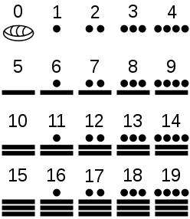

Instructor will model how to do simple addition and subtraction using Mayan numerals.
-Furnish a simple worksheet (10-15 problems) for students to work on in groups.
Day 3 (45 minutes)
To start activity 3, the instructor will put up four to six stations of different Mayan glyphs (days of month, months, planets) and students will walk around in groups writing comments for what they think these symbols mean.
Discuss with the class the concept of a glyph, and other cultures that used them (e.g. Egypt). Be sure students are aware that glyphs are visual depictions of times, dates, numbers or facts used to share knowledge.
Bring exploration reports to front of class, and discuss students’ responses in comparison to what these glyphs actually symbolize.
Instructor will present first Aztec Sage award to a worthy student.
Activity 4 (60 min)
Students will work on jigsaw project which will culminate in a presentation to the class. The idea behind this is to take something such as Mayan glyphs, and have each group of students be responsible for becoming experts and imparting their knowledge to the class. Students will work in partners, and be given a different Mayan glyph for each day of the month.
During this activity, students will:
- Research on the internet the specific glyph symbolized to the Maya (e.g. Jaguar symbolized power, deity).
- Write a brief summary (5-8 sentences) to share with the class during the presentation
- Draw the glyph and write its name on a piece of poster paper provided.
Presentations will be made throughout the rest of the unit, between 4 and 6 per day.
Once presentations are done, posters will be lined up on the wall.

Activity 5 (60 minutes)
Activity five will be a teacher led discussion on the importance of the Aztec calendar. To start, the instructor will pose a series of questions.
-How many days are in a year?
-What does one year signify?
-What is a leap year, and how often does it happen?
From here, the instructor will use a comparative input chart to draw out the two different Aztec calendars. Using mathematics (both conventional and Maya for fun) the instructor will show how the Aztecs (and Maya) produced the lunar calendar and the solar calendar.
After the comparative input chart is finished, the instructor should show some photos of the Piedra del Sol, being sure to take student responses on some of the glyphs they recognize from Activity 4, and some that they are unfamiliar with.
To finish the day, student groups will continue to present their glyph jigsaw presentations, and the instructor will give out the sky watcher award.
Activity 6 (60 minutes)
The instructor will start the class by showing a picture of the observatory at Monte Alban (shown below). Students will pair-share their ideas on what they think this building was for, followed by a brief classroom discussion.
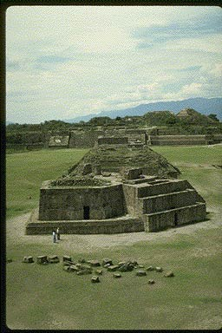
Teacher will distribute a handout that correlates with a pictorial input chart. The input chart will be a drawing of our solar system, with fill in the blanks below certain important celestial bodies.
The instructor should start by sharing that Mesoamerican cultures, most recognizably the Maya, were some of the most renowned astronomers in the world. More than 1000 observatories were constructed by Mesoamerican civilizations.
From here, the instructor will speak briefly on four other celestial bodies (Moon, Sun, Venus, Milky Way), and what they meant to the Maya.
Students will fill in the blanks while the instructor fills in the pictorial input chart. Instructor will make a point to mention that the Maya could predict the orbits (within hours) of all these celestial bodies, and the occurrence of certain events such as eclipses.
Once again, four to six groups will present their glyph jigsaw presentations, and the instructor will give out the sky watcher award.
Activity 7 (60 minutes)
To wrap up the unit, students will work in groups of three to determine some similarities and differences between modern astronomy/mathematics and that of Mesoamerica. Each group will be given a T-graph, and will have fifteen minutes to discuss and come up with their best responses. A classroom discussion will then ensue, and the instructor will fill out a final T-graph on butcher paper or on the whiteboard.
The class’ final assignment will be a writer’s workshop, where students will be required to write two to three paragraphs comparing and contrasting modern versus Mesoamerican technologies.
Instructor will present second Aztec Sage award to a qualified student.
Closure/Assessment
Students should be graded on their participation and portfolio of work (jigsaw, writing assignments, group work, math assignment).
Extended Activities for Integration
Maya Math Olympics (1 day): Instructor will have an extra lesson on how to add up to four places. After, students will work in teams to solve more complex math problems using Mayan math conventions and the vigesimal system.
Create an Aztec calendar (2 days): Student would use the Piedra del Sol as a base point to create their own calendar with their own glyphs. Awards could be given to the students with the most original work, most authentic, etc.
Resources
http://www.michielb.nl/maya/astro.html
http://www.outreachworld.org/Files/florida_internatl_u/MayanMathematicsandArchitecture.pdf
Pensamiento matemático y astronómico en el México precolombino by Guillermo Garcés Contreras

