Unidad temática AP Spanish
Theme – understanding the Mexican Revolution through historical documents, narratives and other authentic sources.

Objectives – 1) Students will be able to discuss in depth and write about historical figures and events
surrounding the revolution
- Students will be able read and discuss important literary works about the revolution
including the ability to produce original ideas about revolutionary topics
- Students will listen to music about the revolution and will be able to identify elements
about the revolution and understand the history through these songs
- Through the previous objectives students will also be able to express their ideas incorporating
vocabulary dealing with the revolution.
- Through the first three objectives the students will use appropriate grammar for the productive
activities specifically focusing on the differences in preterite and imperfect tenses.

La revolución mexicana
1) Group activity – split students into groups of 4 to discuss the following topic. Next, share with the whole class.

¿Qué sabemos de México? ¿Qué influencias han tenido los mexicanos en su cultura y sociedad?

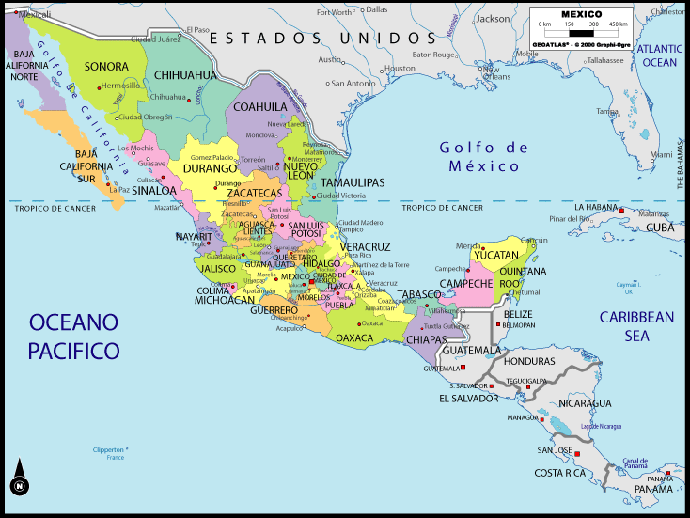
2) Vocabulario de revolución y guerra
The students will have some vocabulary definitions given and others they will need to look up and write definitions in Spanish. They should also write one sentence using the words in appropriate context.

guerra -

liderazgo -

capitán -

el pueblo -

reforma -

milicia-

repartir-

encabezar-

hacendado-

The students will use the following picture to practice with various vocabulary terms. They should write all the items that they can identify in Spanish on the board. Next, they should use the verbs pensar and creer to discuss what the person in the picture is thinking.
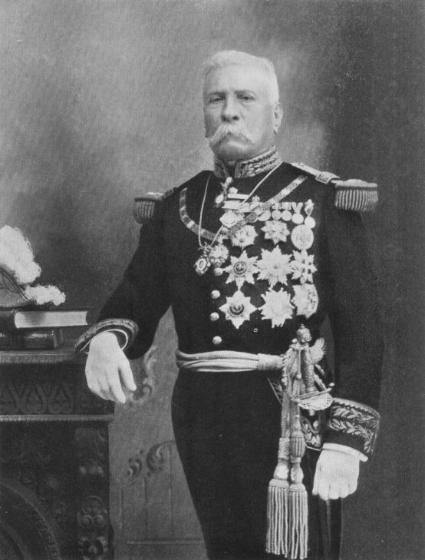
¿Quiénes eran las personas con poder antes de la revolución? ¿Describe la foto? ¿Quién es? (pista – ¿se parece a una persona de la corte real?

The students will write their thoughts in a few sentences and then share out loud. They need to describe what elements in the picture support their opinions.

¿Quién es Porfirio Díaz? ¿Por qué los mexicanos quieren cambios en su país?

¿Qué tipo de revolución es? ¿Hay similaridades con otras revoluciones? ¿La norteamericana? ¿La francesa?

The students will share in a large group the differences they see in the 3 pictures out loud. They will work in pairs to share historical facts about the first 2 revolutions and then compare and contrast with the last. Each group will come to the board and write one idea they came up with. They can use this chart as a study tool for the future.

Historia de la revolución

3) Lectura y presentación del profesor

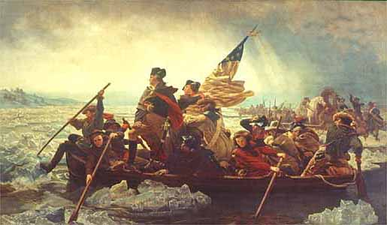
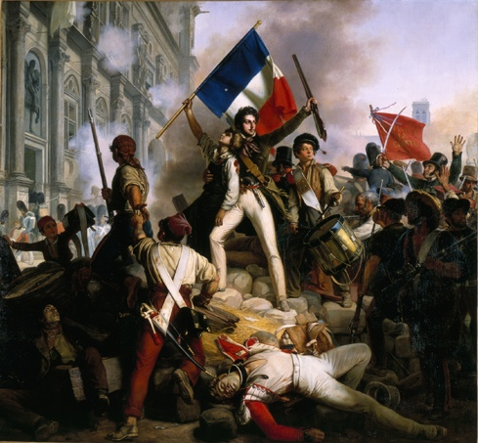
The students will receive handouts from a Power Point that they will also see on the Smart board. They will also have several posters with historical figures and brief biographies.
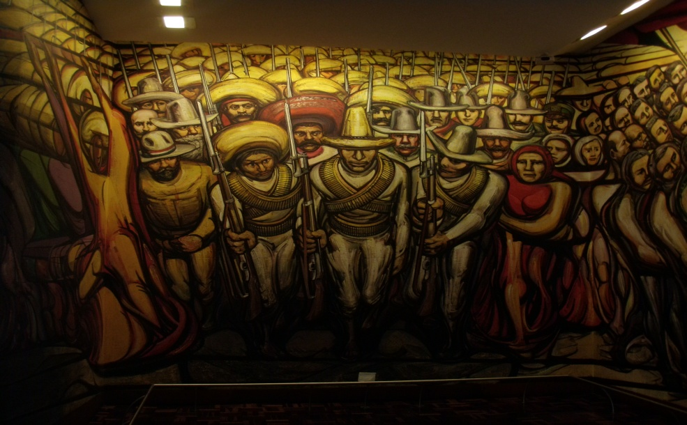

The students will break up into groups to start learning about the historical information about the Mexican Revolution. I will use several informational posters from Mexico. This can be done with any general information though including facts about events, background on the political situation of Mexico along with information on specific important leaders of the revolution.

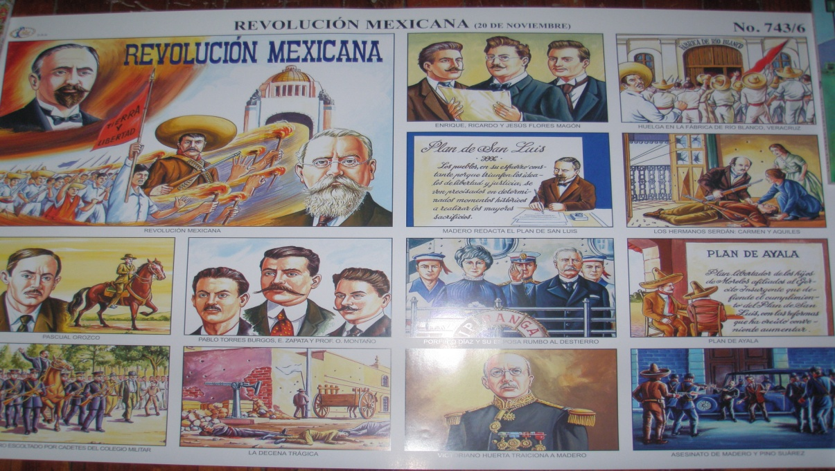
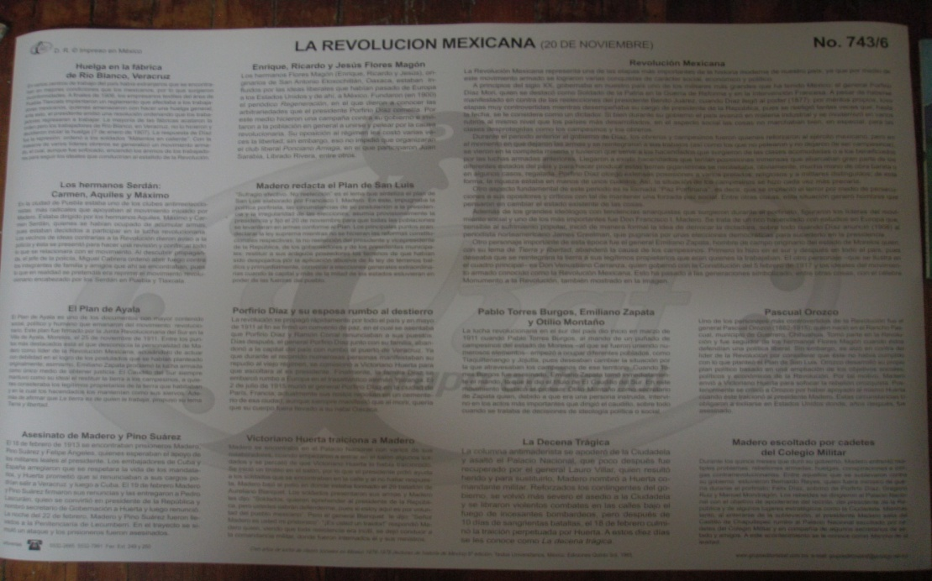
After this activity, each group will be assigned to discuss one element they have read. One might be given the socio-economic conditions preceding the war including the Porfiriato. Another group would explain an important battle and another one important historical figure such as Pancho Villa, Madero, etc.

This is also an opportunity to introduce the uses of the imperfect and preterite tenses using activities from appropriate grammar texts. This will be helpful when the students begin to speak and write about the pasts events with appropriate grammar usage. These could include “cloze” activities.

The next activity covers several days and includes the viewing of parts of several videos. They include the following:

2 days: Mexico: Revolution and Rebirth. History Channel, 1999. This is for general historical information.

2days: 1) Scenes from Como agua para chocolate that show the mother discussing the lack of
danger of the revolution and the rogue soldiers coming in and killing the mother. This
shows the chaos and danger that the revolution brought on as well as the views from the
priveledged classes.
    - Scenes from the movie “Old Gringo” to show the closeness of the American influence and fear in the Mexican Revolution.
    - Show scenes from the Mexican telenovela “El vuelo del águila” to emphasize the damage done during the Porfiriato as well as the taking of power by Madero.

The students in groups will create a time-line of major events of the revolution and will write this time-line on their paper as well as a larger example on the board where all the students will participate.

4) La música y la mente popular en la Revolución Mexicana

In this section the students will discuss the importance of song in the memory and history of Mexico. They will focus on the use of “corridos” by the Mexican populace to remember the events of the past and to explain their present situation.

First the teacher will form several questions about folkloric music and its importance in the United States.

Preguntas:

¿Cuáles son algunos ejemplos de canciones folclóricas de los EE.UU.? Nombra algunas tanto del presente como del pasado. ¿Qué importancia tienen estas canciones en la memoria colectiva? ¿Por qué escribimos estas canciones?

Here the teacher should focus the students on the importance of people to explain their history through song. Include the fact that many people were illiterate and/or did not have access to books and therefore needed songs to understand their own history and circumstances.

Next, the students will be shown a painting from the War of 1812 and a translation of the Star-Spangled banner in Spanish. They will comment in small groups about the history of the event that Francis Scott Key wrote (originally in the form of a poem) and why it became so famous.

Following this, the students will listen to a “corrido” called “Tiempos amargos” which describes the feelings of the peasants and people suppressed by the revolution.

Tiempos amargos

Ay, qué contentos hemos llegado
a estos tiempos que ahora se ven!
Nosotros somos los agraristas,
varios amigos que ni lo creen.

Ya no es el tiempo del porfirista,
que antes lloraban por el patrón,
que lo encontraban, le dan la mano,
y le abrochaban el pantalón.

Y si algún día el mayordomo
se desgustaba con algún peón
era porque otro andaba más cerca
a los remaches del pantalón.

Y el que tenía hijas bonitas
ahí se la daban de velador,
o se granjeaban muy buena chamba
o cuando menos de rayador.

El que tenía mujer bonita
no lo dejaban ni descansar,
los levantaban muy de mañana
como a los bueyes a trabajar.

Ya me despido de mis amigos
ahí me dispensan la indiscreción,
tiempos amargos del porfirista
que aquí les canto en mi canción.

From the following link you can access this “corrido” as well as several others that can be used for the lesson.

http://artsedge.kennedy-center.org/interactives/lessons/corridos/corridos.swf

A possible activity for this lesson would be to create a cloze activity in which several words or lines are omitted and the students must listen to the audio and fill in the missing words.

Preguntas:
The students should answer the following questions in small groups and then share with the whole class. The students will also be told that they will be required at a later point to analyze another corrido as part of a larger assessment.

¿Qué sentimientos muestra el cantante en el corrido?

¿Qué época describe?

¿Cuál es el propósito del escritor de este corrido?

¿Qué tiene que ver esta canción con la revolución mexicana?

Vocabulario

The students should define the following vocabulary terms that might be unknown to them

mayordomo -

buey -

granjear -

chamba (coloquial) -

El fracaso y la novela de la revolución

The students will next be presented with further information about the revolution and the positive and negative effects of the revolution. I will emphasize the horrors of not only this war but also stress the negative consequences that always occur during war. They will learn about the ideals that were fought for during the Mexican Revolution and how some were achieved while many were not.

Lectura: Un fragmento de Los de abajo de Mariano Azuela

The students will be given a brief narrative on the life and times of Mariano Azuela. They will be told about his own actions during the Mexican Revolution and about the writing of this short novel after fleeing to the United States.

Below is a link to read parts of the novel. The students should read the following selection and answer the following questions:
http://www.isbnlib.com/preview/9871136625/Los-de-abajo-Spanish-Edition

¿Quiénes son los personajes en este pasaje?

¿Quién está a cargo de este grupo de milicias?

¿Cuál es el tono del pasaje escogido?

¿Cómo se puede ver el desorden de la revolución en esta parte?

¿Qué hace Demetrio para salvar a la mujer?

The students should note any vocabulary terms that prevent them from understanding the story and make a list with definitions written in Spanish.

Final Assessment – La revolución mexicana

- Parte auditiva
The students will listen to a corrido two times and write a summary of the theme. They should be able to relate the events from the song with events that they have learned about from the Mexican Revolution. Se llama “El corrido de la vida y muerte del general Francisco Villa”.

http://artsedge.kennedy-center.org/interactives/lessons/corridos/corridos.swf

Instrucciones para el alumno:

Vas a escuchar un corrido que tiene que ver con la revolución mexicana. Debes de describir el corrido y su relación con la revolución.

a) Identifica a las personas importantes que mencionan y explica por qué son importantes en la revolución.

b) Identifica los eventos importantes que se mencionan

c) ¿Por qué crees que fue escrito y cantado este corrido?

- Identificación Visual
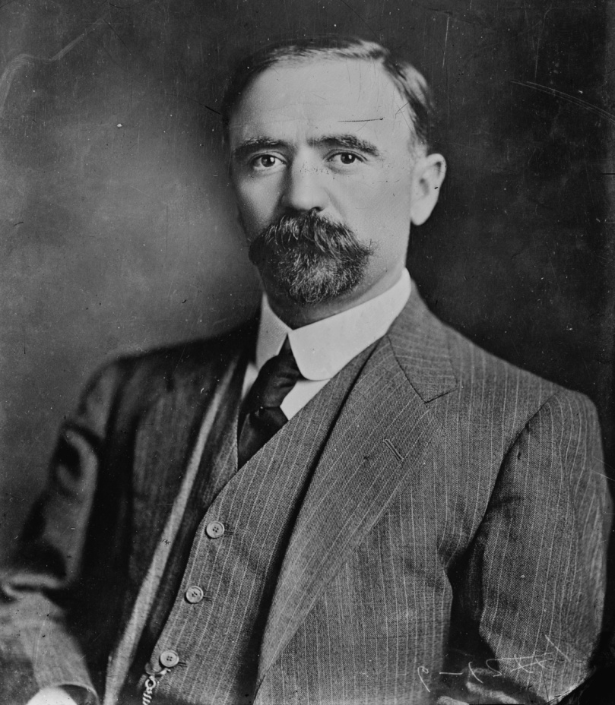
The students will be shown a picture of a famous person from the Revolución and will be asked to identify who it is and write a paragraph describing his importance.

- Análisis de lectura
The students will be given a short sample from the novel Los de abajo and will be asked to analyze the selection.

Instrucciones para el alumno:

Aquí hay una selección del libro Los de abajo de Mariano Azuela. Debes leerla y contestar algunas preguntas.

http://www.isbnlib.com/preview/9871136625/Los-de-abajo-Spanish-Edition

a) ¿De qué trata este pasaje de la novela?

b) ¿Quiénes son los personajes importantes?

- ¿Qué está criticando aquí Azuela?

d) ¿Cómo es similar/diferente del otro pasaje que leíste?

- Parte oral
The students will form groups in which a group of 3 or 4 students will be given the role of one of the important people relating to the Revolution. They will stand in front of the class and will be held to a jury of the teacher and their peers. They will be asked questions pertinent to their character and will have to explain their actions relating to the Revolution and justify them to the class.

The students will prepare some questions for the other groups on the day/s of the assessment and the teacher will also have a list of questions available to ask. All students in the group will have ample opportunity to answer questions and will be evaluated based on their individual responses to the questions asked.

Lista de posibles personas:

Huerta
Díaz
Madero
Villa
Carranza
Zapata

The rubrics for each section except for part three will be a modified version of the AP rubrics and the students will be scored based on their responses to the four individual sections. Part three will be scored based on points received for adequately answering the questions given.

http://www.collegeboard.com/prod_downloads/ap/students/spanish/ap07_spanish_lang_writing_speaking_sgs_final.pdf

These will be the rubrics used for the evaluations.

Optional References

Additional Films and Documentaries:

El violín (director Francisco Vargas).
Los de abajo (director Servando González)
Ora sí tenemos que ganar (director Raúl Kmffer)
La milpa by Patricia Riggen, 2002 (short film, 27 minutes)
The Storm that Swept Mexico: http://www.pbs.org/itvs/storm-that-swept-mexico/the-revolution/maps-revolution/

Additional Historical Source:

Krauze, Enrique. Biografía del poder: Caudillos de la Revolución Mexicana (1910-1940). Barcelona: Tusquets Editores, 1997.

Additional Short Story:

"De como al fin lloró Juan Pablo" de Mariano Azuela (a short story written before Los de abajo; it presents a critical vision of the Mexican Revolution)

Additional Resource to find segments of the novel Los de abajo:

Literatura de La America Hispánica: Antologia e Historia. Tomo III: La Época Contemporánea by Frederick S. Stimson and Ricardo Navas-Ruiz (1975)

